Lab session – data base creation and quering
- Create a database with name StudentRepo and create the columsn with have promary key and not null constraints
- Insert the below mentioned row and columns in the database.
- Update the marks of Arnold as 70 inpace of 55
- Delete the row of Tes Qry as she has left the college
- Arrange the columns of Mark in ASC and DESC order to check on who have received the highest and lowest marks
- Select only the female candidates and display to check on how many girl students are enrolled
- Write a query to select the student who scored the lowest marks
- Write a query to select the student who scored the highest marks

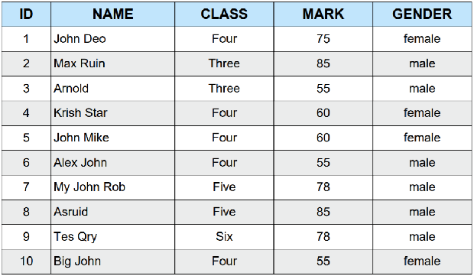

2. From the following table, write a SQL query to find out which nurses have not yet been registered. Return all the fields of nurse table.
Sample table: nurse
Sample table: nurse

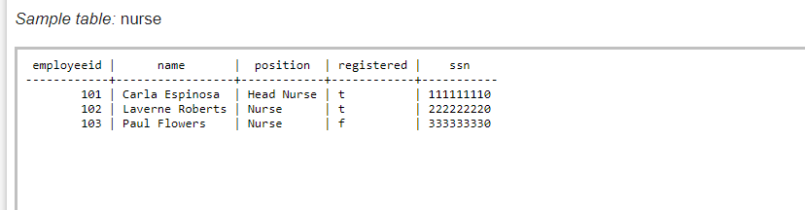Sample Output:
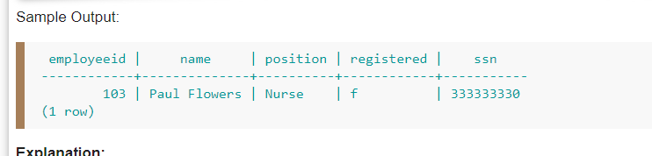

3.From the following table, write a SQL query to identify the nurses in charge of each department. Return nursename as “name”, Position as “Position”.
Sample table: nurse
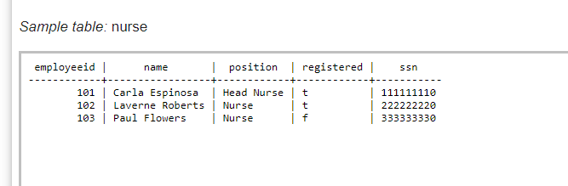
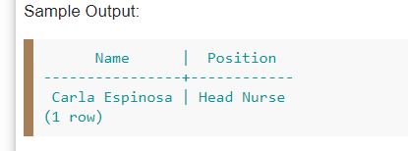
4. From the following tables, write a SQL query to identify the physicians who are the department heads. Return Department name as “Department” and Physician name as “Physician”.

Sample table: physician

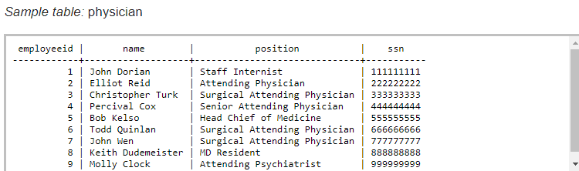

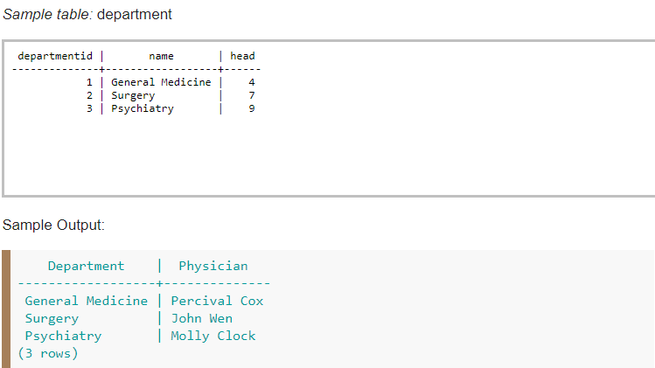

5. From the following tables, write a SQL query to find all salespeople and customers located in the city of London.

Sample table: Salesman
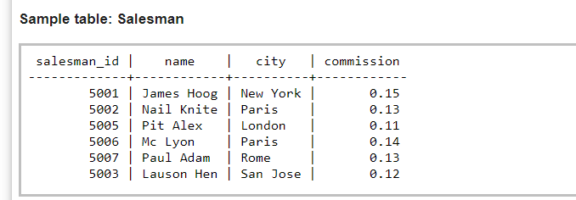

Sample table: Customer

